Guide to Update Content for the San Francisco Neighborhood Centers Together (SFNCT) Website

Admin Guide for WordPress 3

Codex 3

Administration Screens 3

WordPress Admin Guide Site 4

Admin Guide for San Francisco Neighborhood Centers Together (SFNCT) Website 5

Administration Screen Login Page 5

How Do I Update the Site Title 6

How Do I Update the Pages 8

How Do I Update the Menus 10

The Media Library and Your Upload Images 12

How Do I Add Images to the Slider on the Homepage 13

How Do I Update SFNCT Contact Information 16

How Do I Customize Themes 17

How Do I Change Themes 18

Member Only Announcements 19

Login Member Only Announcements 19

Member Only Announcements Dashboard 19

Edit Member Only Announcements 20

Delete Member Only Announcements 21

Add Member Only Announcements 21

Member Only Announcements Attachments 21

Figure 1: Administration Screens 3

Figure 2: Administration Screen - Login Page 5

Figure 3: SFNCT - Site Title 6

Figure 4: Administration Screen - General Settings 7

Figure 5: SFNCT - Pages 8

Figure 6: Administration Screen - Pages 9

Figure 7: Administration Screen - Edit Page 9

Figure 8: SFNCT - Menus 10

Figure 9: Administration Screen - Menus 11

Figure 10: Administration Screen - Media Library 12

Figure 11: SFNCT - Image Slider 13

Figure 12: Administration Screen - Posts 14

Figure 13: Administration Screen - Add Slider Options 14

Figure 14: Administration Screen - Post ID 15

Figure 15: Administration Screen - Widgets 16

Figure 16: Administration Screen - Customize Theme 17

Figure 17: Administration Screen - Change Theme 18

Figure 18: Login Member Only Announcements 19

Figure 19: Member Only Announcements Dashboard 20

Figure 20: Edit Member Only Announcements 20

Figure 21: Add Member Only Announcements 21

Figure 22: Member Only Announcements Attachments 22

Figure 23: Attachment Max Size 22

# Admin Guide for WordPress

## Codex

As quoted at <http://codex.wordpress.org/>, Codex is “the online manual for WordPress and a living repository for WordPress information and documentation.“

I would not get bogged down with all the information at Codex except that it exists and it is the starting point if you have a WordPress question or issue.

### Administration Screens

The Administration Screens is a subsection of the Codex. As quoted at <http://codex.wordpress.org/Administration_Screens>, “The Administration Screen provides access to the control features of your WordPress installation. Each Administration Screen is presented in sections, the toolbar (and header), the main navigation, the work area, and the footer.” In other words, WordPress provides you with an admin tool that will assist customizing your site and maintain the content.

Below is a list of WordPress Administration Screens. The areas circled in yellow are the screens one would frequent to update the SFNCT content.

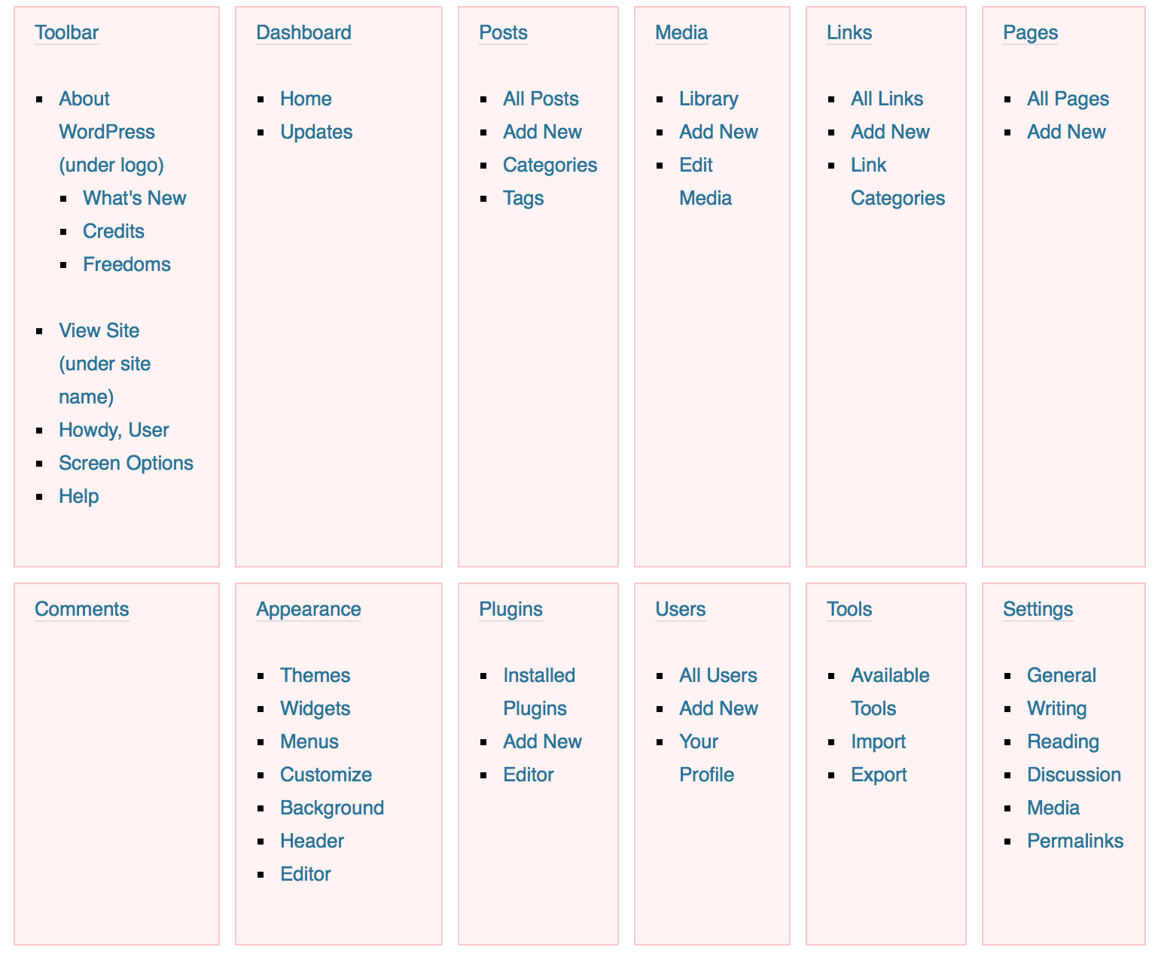

Figure : Administration Screens

## WordPress Admin Guide Site

The Codex is the official documentation for WordPress.

The WordPress Admin Guide Site provides another resource on the WordPress Administration Screens. <http://wp-admin-guide.com/>

As quoted from the home page of their site, “The WordPress Admin Guide is intended for ordinary folks who got a WordPress site and are now pouring contents into it. Normally, a professional web developer would setup the site for you. Your job now is to manage the site’s contents. This site will guide you through it.“

I would highly recommended giving this site a once over read.

# Admin Guide for San Francisco Neighborhood Centers Together (SFNCT) Website

## Administration Screen Login Page

<http://wp-admin-guide.com/how-to-admin-wordpress/logging-in/>

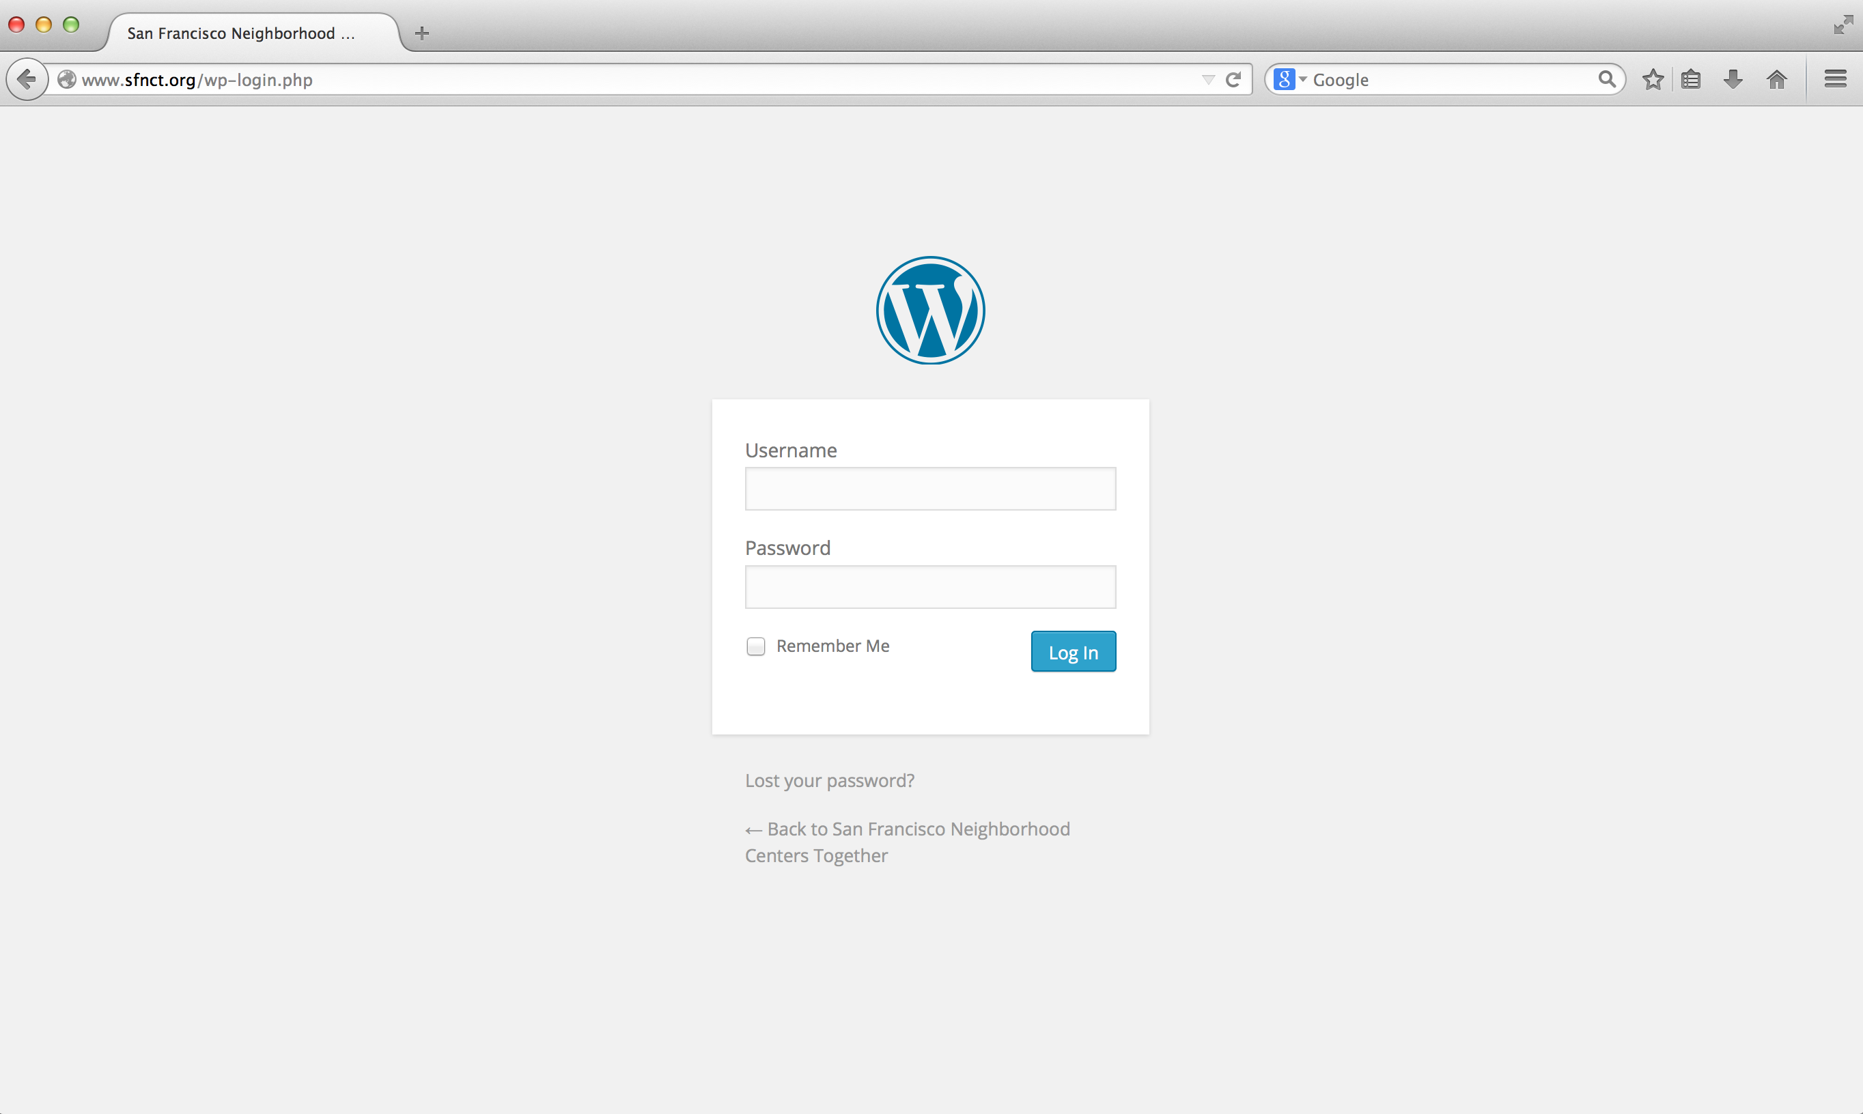

Figure : Administration Screen - Login Page

1. Go to the WordPress Administration Login page for SFNCT.

<http://www.sfnct.org/wp-admin/index.php>

1. Enter Username and Password for a user with an Administrator role and select the Log In button.

User Name: admin

Password: wordpress

1. After you log in, the default page of the WordPress Administration is the Dashboard Screen.

<http://wp-admin-guide.com/how-to-admin-wordpress/the-dashboard/>

## How Do I Update the Site Title

<http://wp-admin-guide.com/how-to-admin-wordpress/the-settings-menu/>

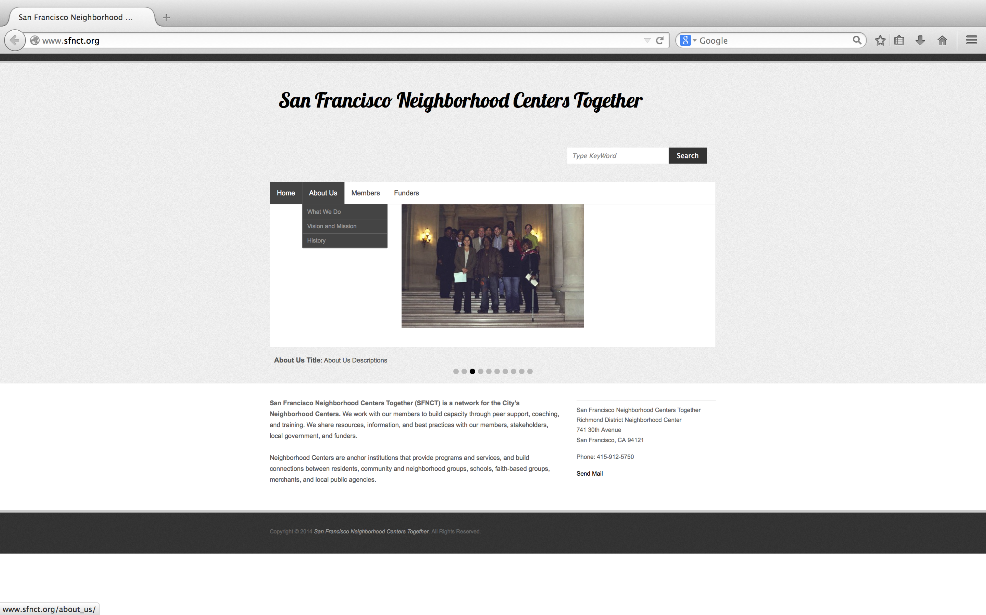

Figure : SFNCT - Site Title

1. Log on the WordPress Administration for SFNCT.
2. From the left side panel, select “Settings 🡪 General” or go to <http://www.sfnct.org/wp-admin/options-general.php>
3. Update Site Title text box and select the Save Changes button.

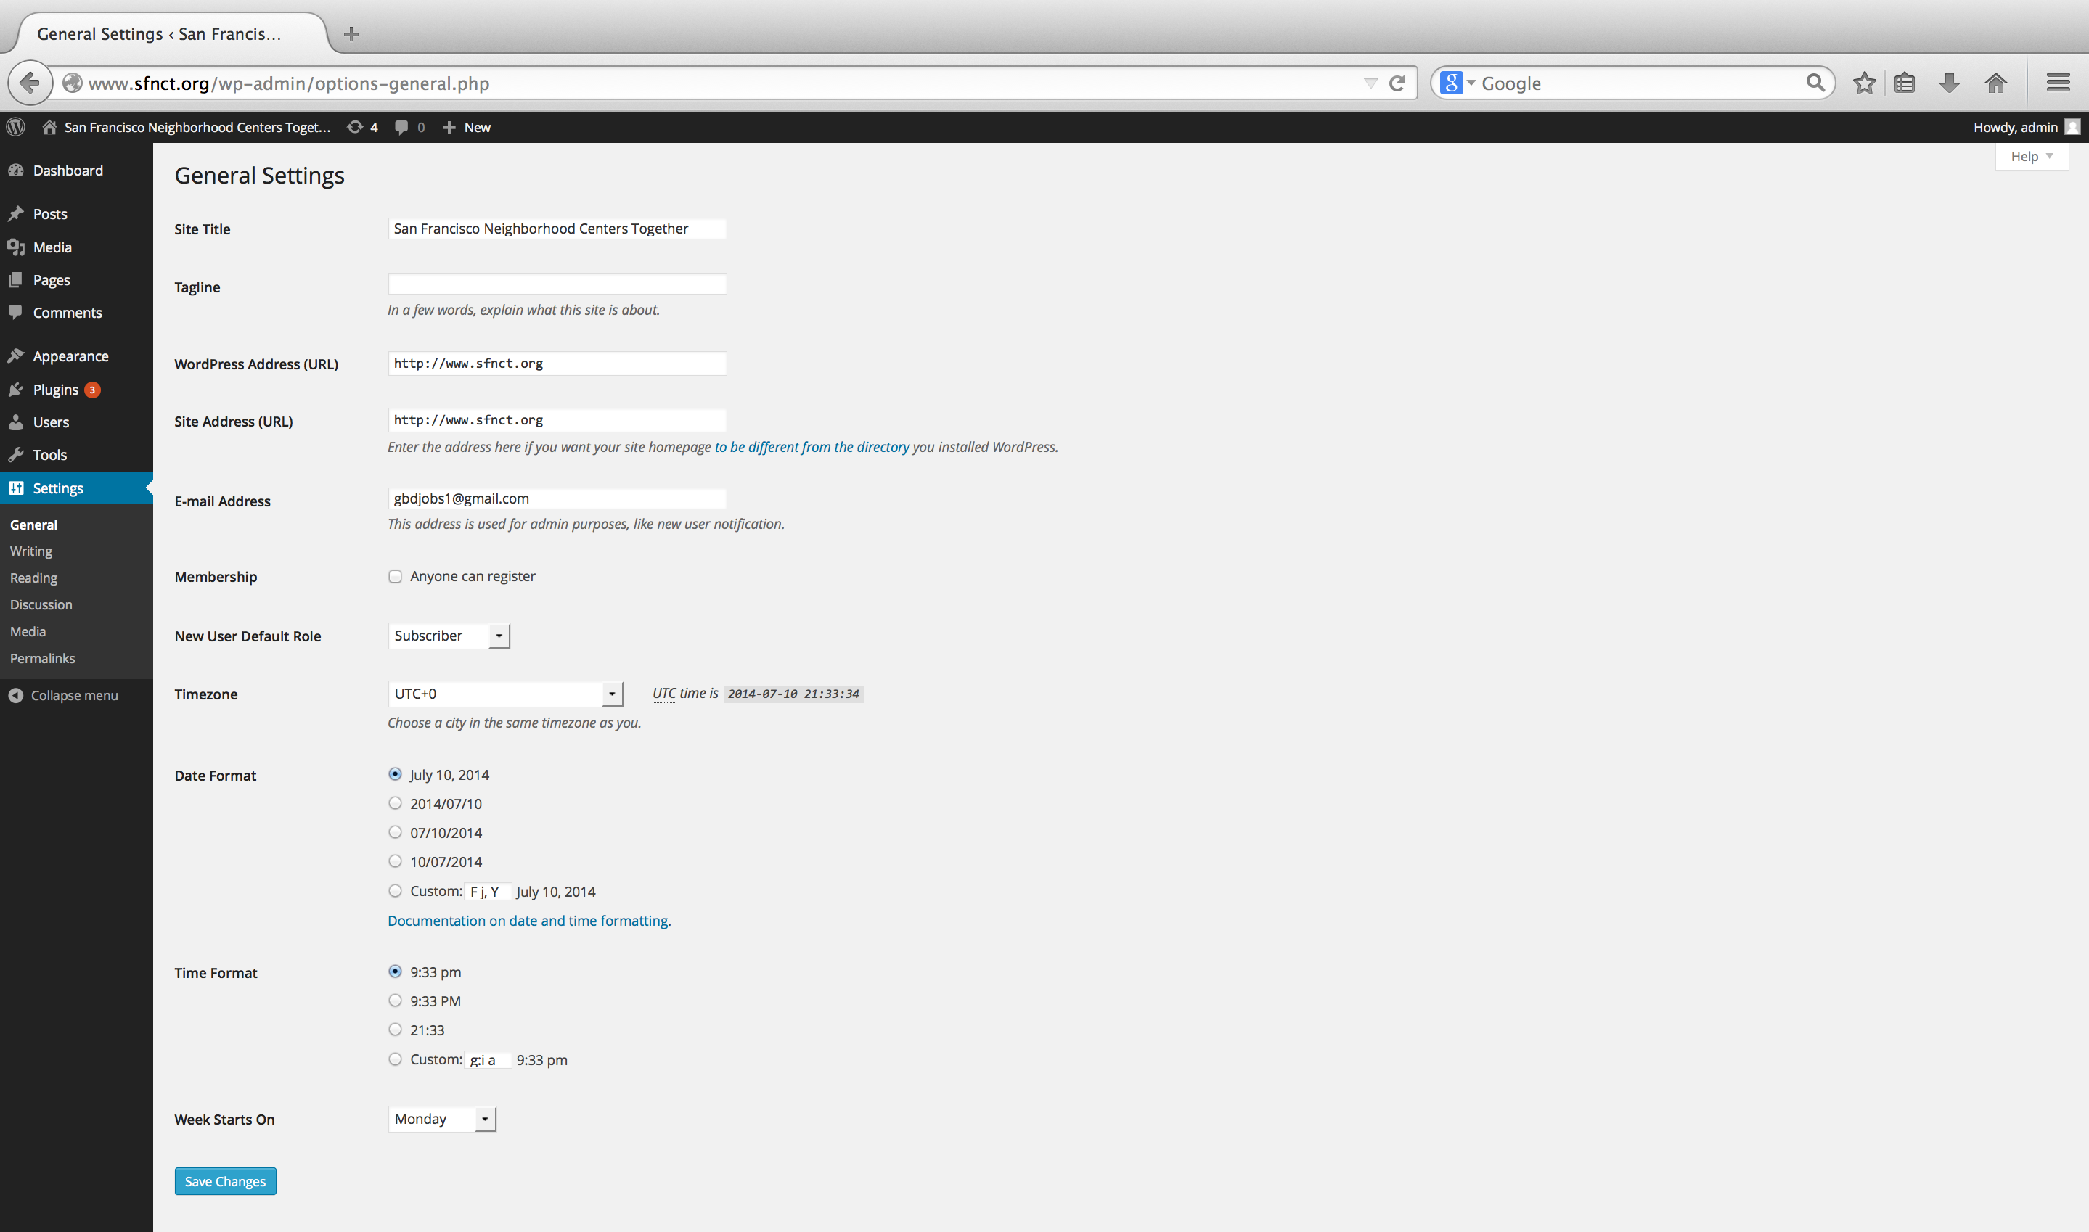

Figure : Administration Screen - General Settings

## How Do I Update the Pages

<http://wp-admin-guide.com/how-to-admin-wordpress/writing-posts-and-pages/>

<http://wp-admin-guide.com/how-to-admin-wordpress/working-with-pages/>



Figure : SFNCT - Pages

1. Log on the WordPress Administration for SFNCT.
2. From the left side panel, select “Pages” or go to <http://www.sfnct.org/wp-admin/edit.php?post_type=page>
3. Select the Page name hyperlink or right-click the Page name and select Edit, and the Edit Page will be launched.
4. On the Edit Page, update the page content and select the Update button.

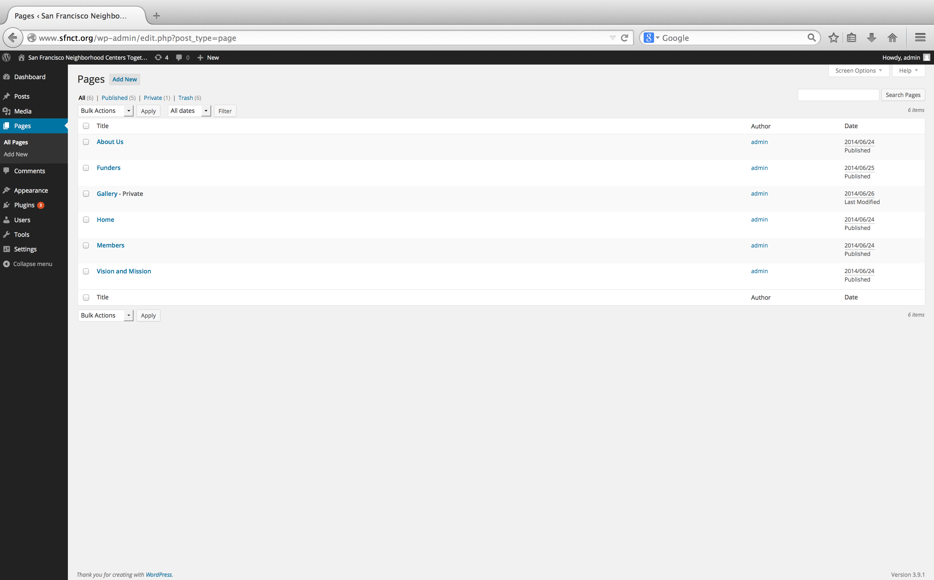

Figure : Administration Screen - Pages

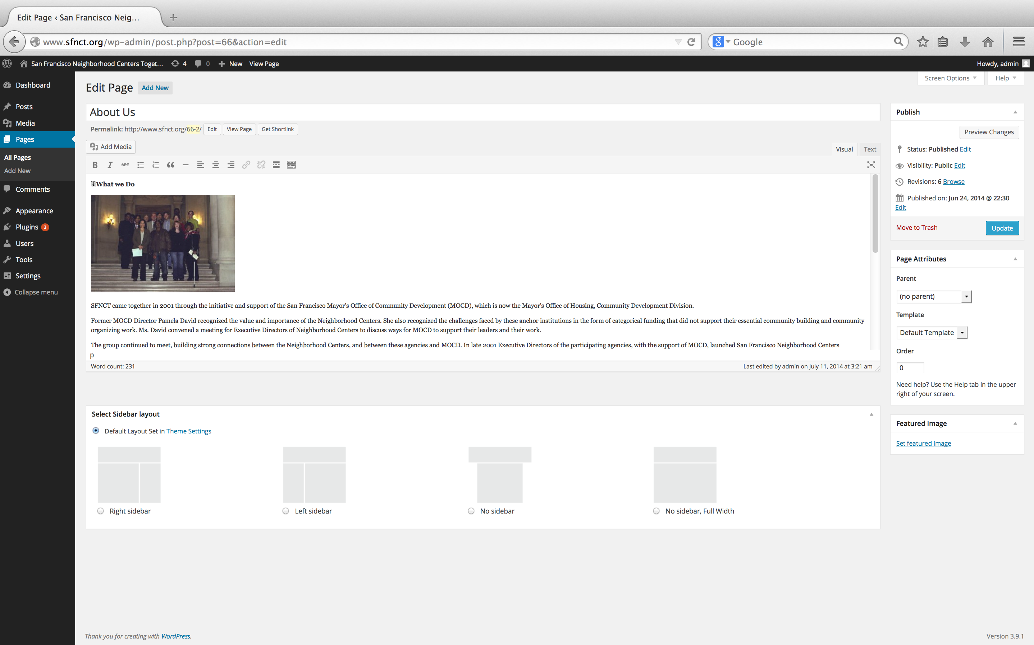

Figure : Administration Screen - Edit Page

## How Do I Update the Menus

<http://wp-admin-guide.com/how-to-admin-wordpress/working-with-menus/>

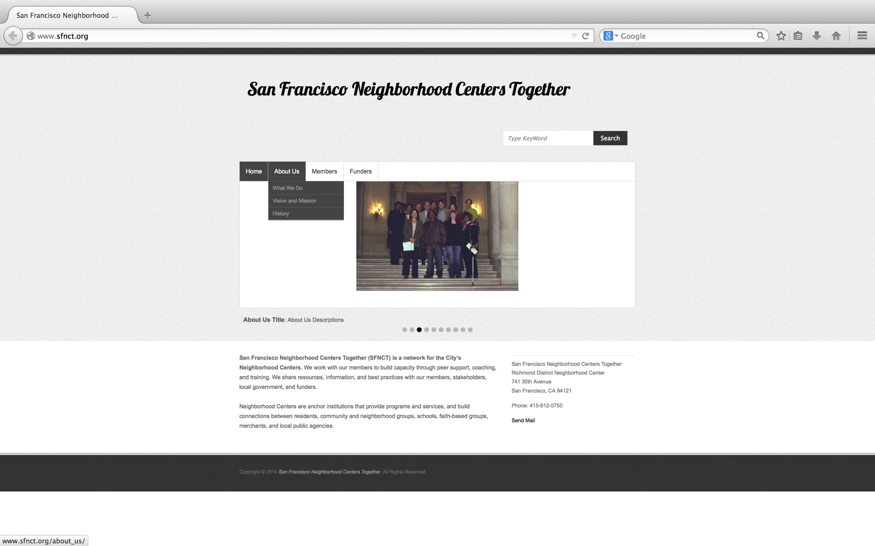

Figure : SFNCT - Menus

1. Log on the WordPress Administration for SFNCT.
2. From the Dashboard Screen, select “Appearance 🡪 Menus” or go to <http://www.sfnct.org/wp-admin/nav-menus.php>
3. The right panel, Menu Structure, displays the current menu. A menu item displays either it references a Page or Custom hyperlink. The referenced page is one of the available pages from the Administration Screen Pages and is listed on the left panel. By default, a new page will automatically be added to the current menu. If you remove a Page from the Menu, you can always re-add it by dragging the page from the left Page panel to the right Menu Structure panel. A Custom hyperlink references a hyperlink that is not specifically a page. For example, a custom hyperlink was created for the What We Do and History menu items so a user would be forwarded to a particular section within the About Us page. The Navigation Label displays the Menu title. The menu items that are right indented are submenus. For instance, What We Do, Vision and Mission, and History menu items are submenus to the About Us menu item.

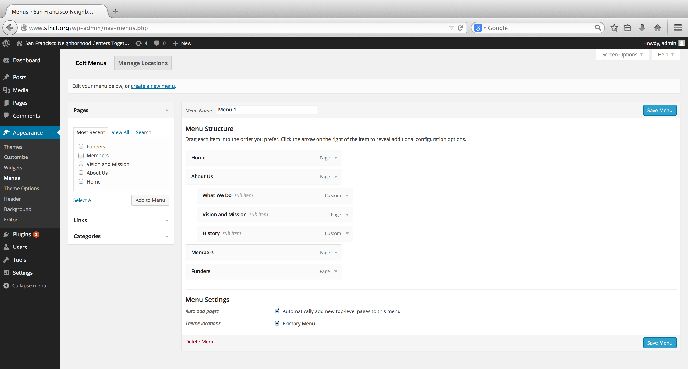

Figure : Administration Screen - Menus

## The Media Library and Your Upload Images

<http://wp-admin-guide.com/how-to-admin-wordpress/uploading-media-files/>

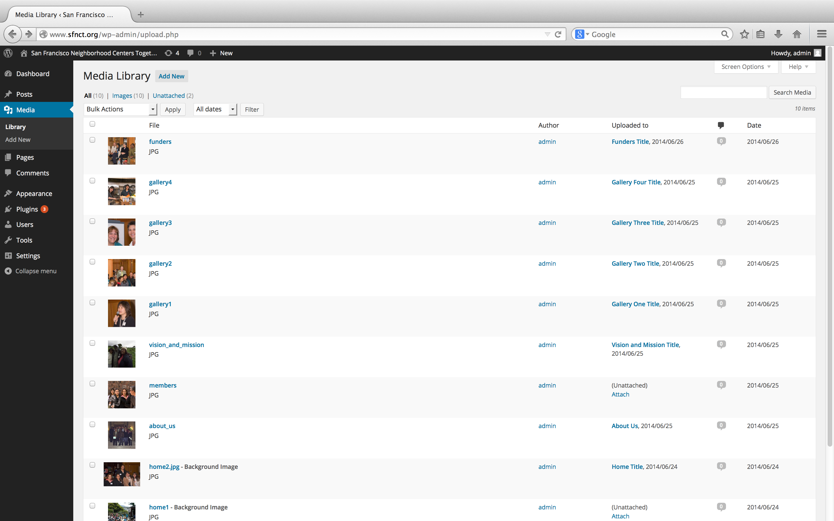

Figure : Administration Screen - Media Library

1. Log on the WordPress Administration for SFNCT.
2. To view all uploaded images, from the Dashboard Screen, select “Appearance 🡪 Media” or go to <http://www.sfnct.org/wp-admin/upload.php>. To remove an image(s) select the checkbox(s) and select Delete Permanently and then Apply button or the Delete Permanently hyperlink to delete one image.
3. To add a new image, from the Dashboard Screen, select “Appearance 🡪 Media 🡪 Add New” or go to <http://www.sfnct.org/wp-admin/media-new.php>. On the Upload New Media page, drag and drop the image in the box or select the Select Files button.
4. The new images will be added to the wp-content/uploads/ folder.

## How Do I Add Images to the Slider on the Homepage

The image slider on the homepage displays the Featured Images from selected Posts.



Figure : SFNCT - Image Slider

1. Add images to the Media Library.
2. Create new Posts that reference a Feature Image.

<http://wp-admin-guide.com/how-to-admin-wordpress/writing-posts-and-pages/>

<http://wp-admin-guide.com/how-to-admin-wordpress/managing-posts/>

1. From the left side panel, select “Posts 🡪 Add New” or go to <http://www.sfnct.org/wp-admin/post-new.php>
2. Add a Post title. The Post title is displayed when one hovers over the image displayed in the slider.
3. Set a Featured Image.

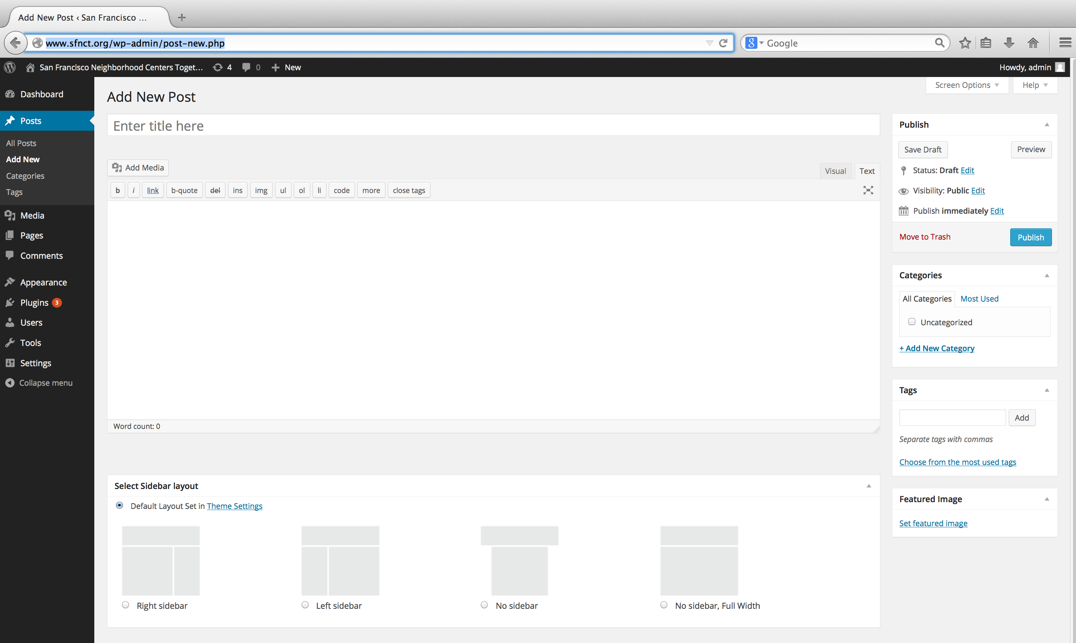

Figure : Administration Screen - Posts

1. Reference Post Ids in the Featured Post Slider.
2. From the left side panel, select “Appearance 🡪 Theme Options (<http://www.sfnct.org/wp-admin/themes.php?page=theme_options>) 🡪 Featured Post Slider 🡪 Add Slider Options”.
3. Add the number of image slides to display and the referenced Post ID of the Featured Image.

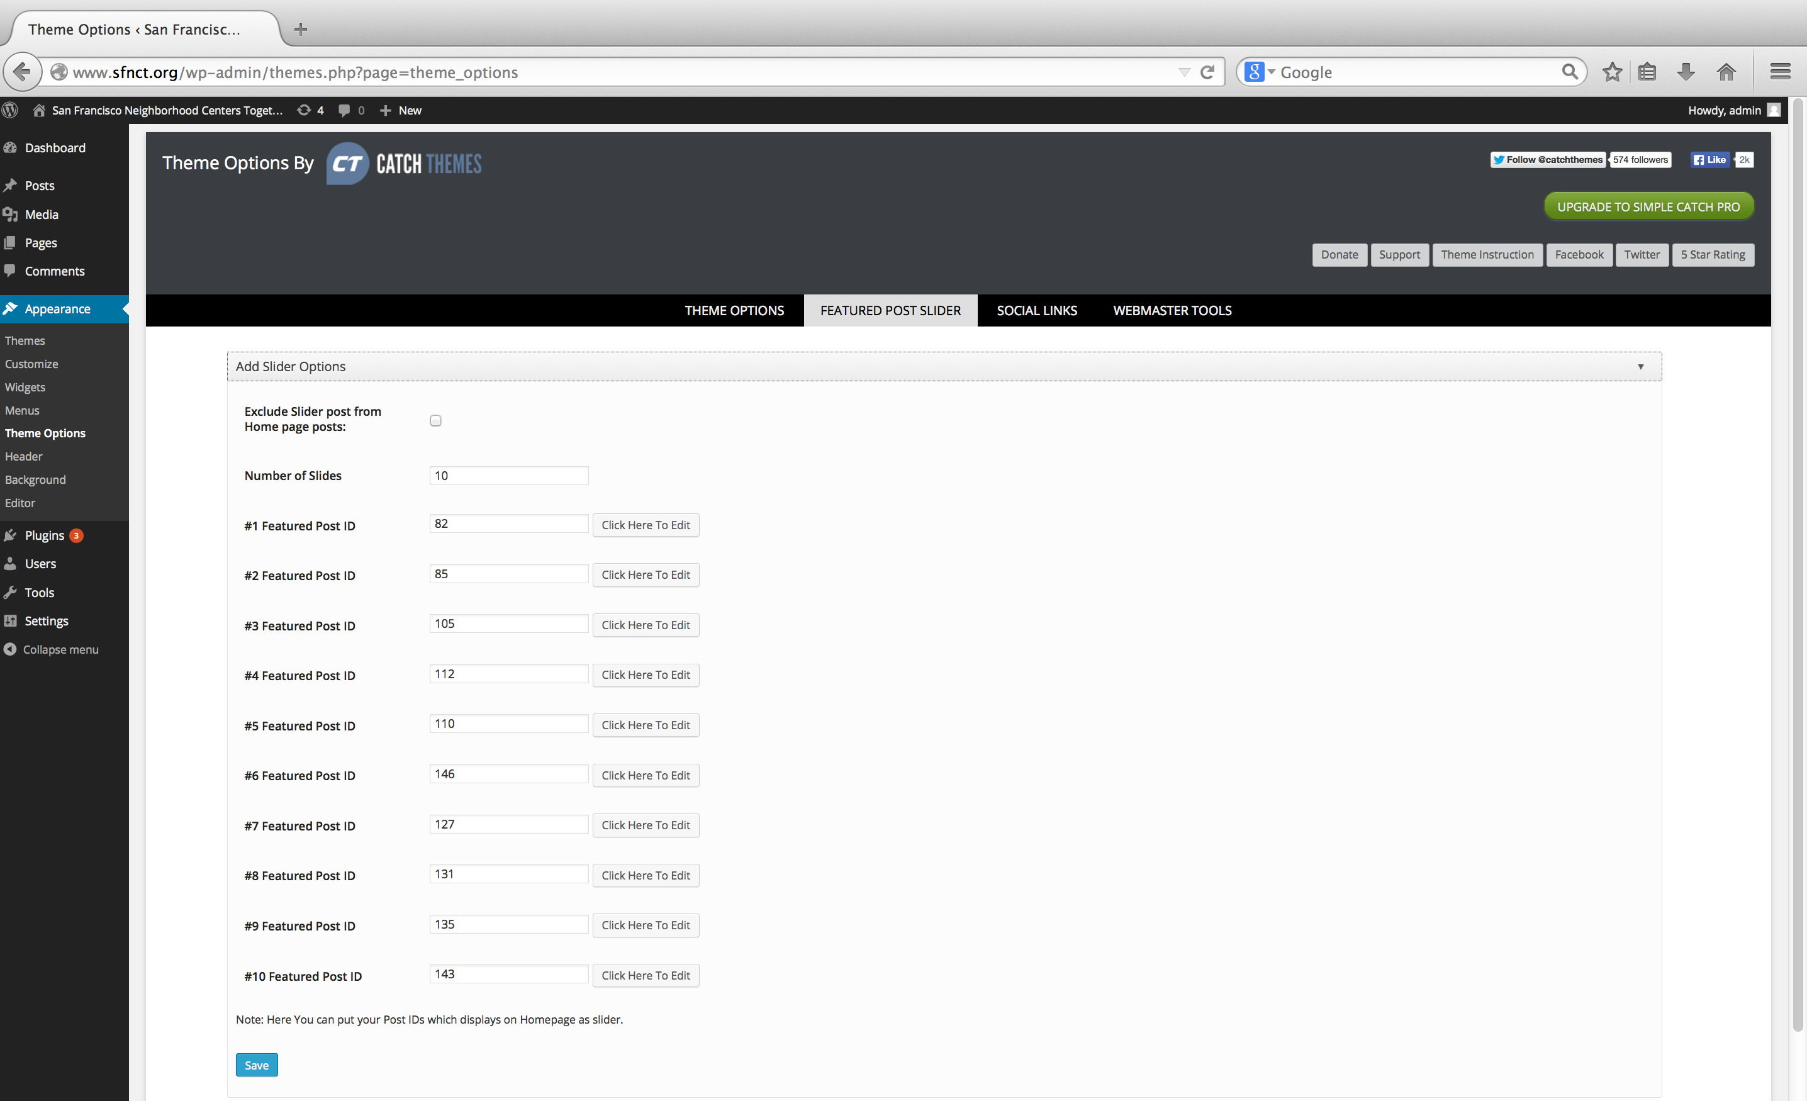

Figure : Administration Screen - Add Slider Options

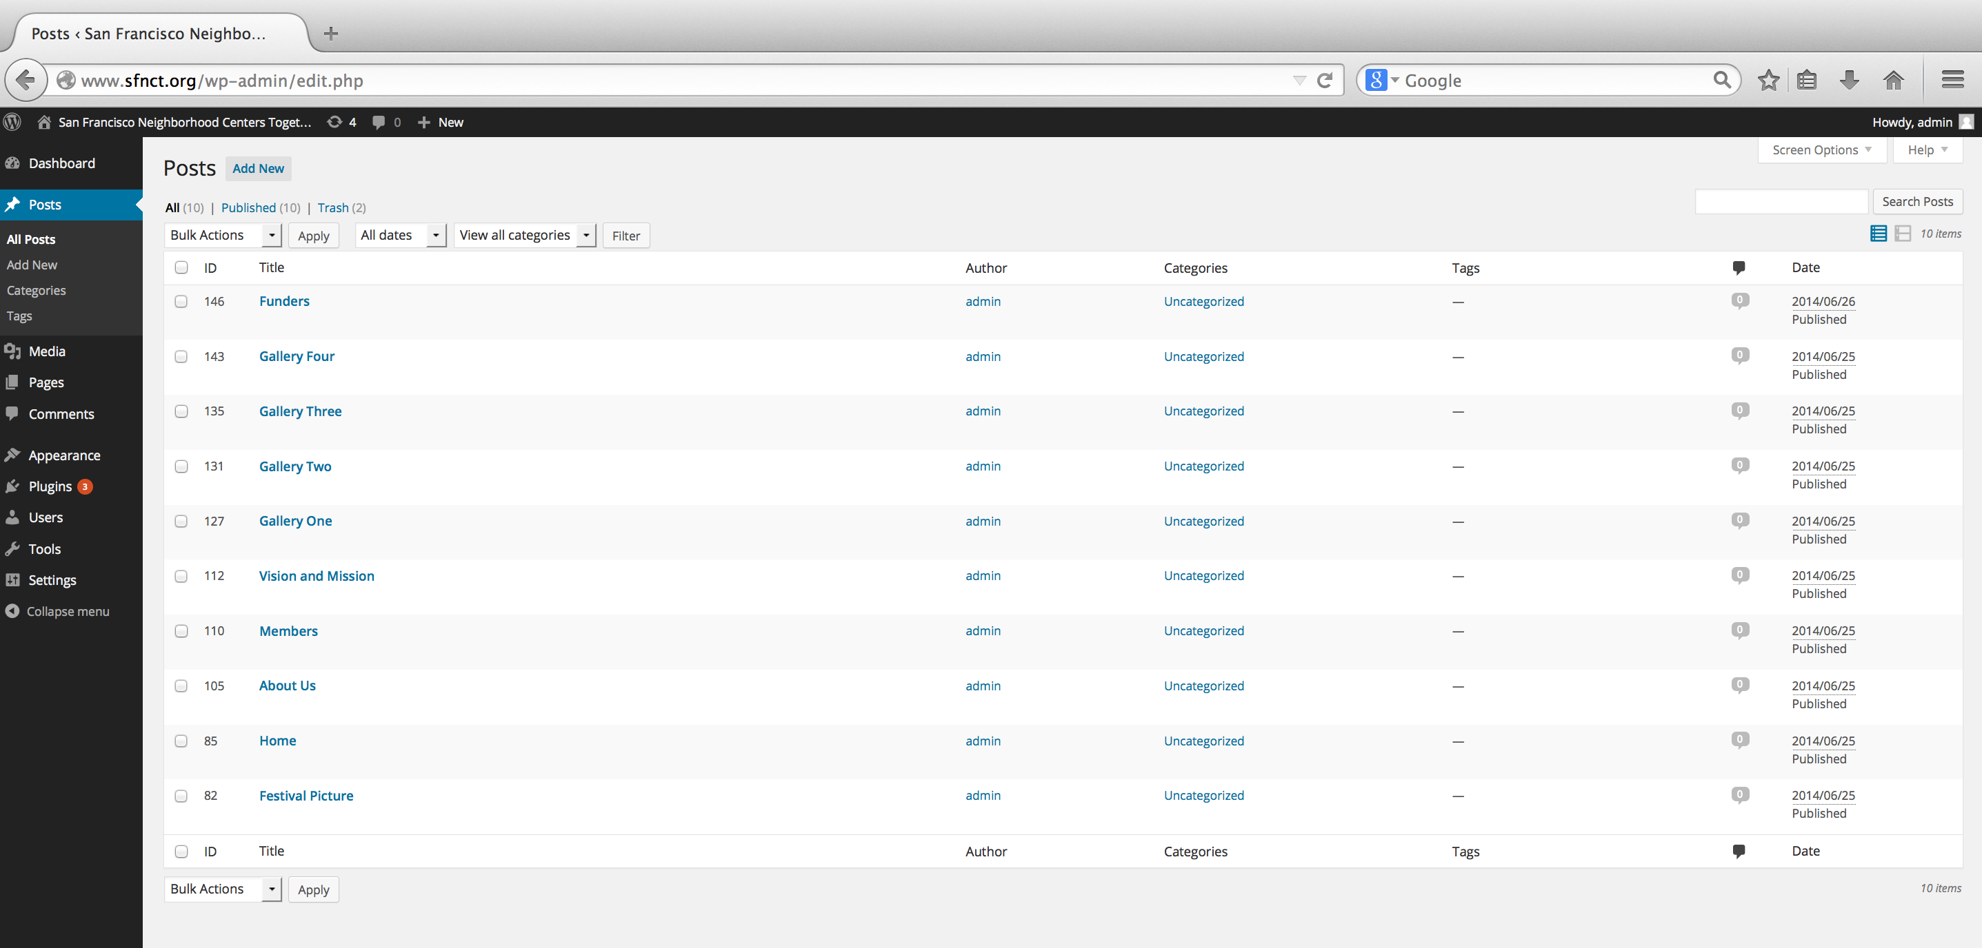

Figure : Administration Screen - Post ID

1. The Featured Post Slider creates hyperlinks that reroute back to the referenced Post. That is the not the desired intent for the SFNCT website.

The Featured Images should link to the referenced Pages. For this action, an update was made to the php file from the Simple Catch theme. For each additional image that is added to the Featured Post Slider that needs a hyperlink created to the referencing page needs to update this php file.

* 1. Open wp-content/themes/simple-catch/functions/simplecatch_functions.php
  2. Modify the simplecatch_sliders function.
  3. On roughly line 372, add to the If-Else statement where Post ID equals the Feature Image create a hyperlink to the referenced Page.

**if** ($post->ID==82){

//home

$simplecatch_sliders .= '<a href="' . get_bloginfo('url') . '/" title="'.the_title('','',**false**).'">';

}**else if** ($post->ID==85){

//home

$simplecatch_sliders .= '<a href="' . get_bloginfo('url') . '/" title="'.the_title('','',**false**).'">';

}**else if** ($post->ID==105){

//about us

$simplecatch_sliders .= '<a href="' . get_bloginfo('url') . '/about_us/" title="'.the_title('','',**false**).'">';

}**else if** ($post->ID==112){

//vision and mission

$simplecatch_sliders .= '<a href="' . get_bloginfo('url') . '/vision_mission/" title="'.the_title('','',**false**).'">';

}**else if** ($post->ID==110){

//members

$simplecatch_sliders .= '<a href="' . get_bloginfo('url') . '/members/" title="'.the_title('','',**false**).'">';

}**else if** ($post->ID==146){

//funders

$simplecatch_sliders .= '<a href="' . get_bloginfo('url') . '/funders/" title="'.the_title('','',**false**).'">';

## How Do I Update SFNCT Contact Information

<http://wp-admin-guide.com/how-to-admin-wordpress/using-sidebar-widgets/>

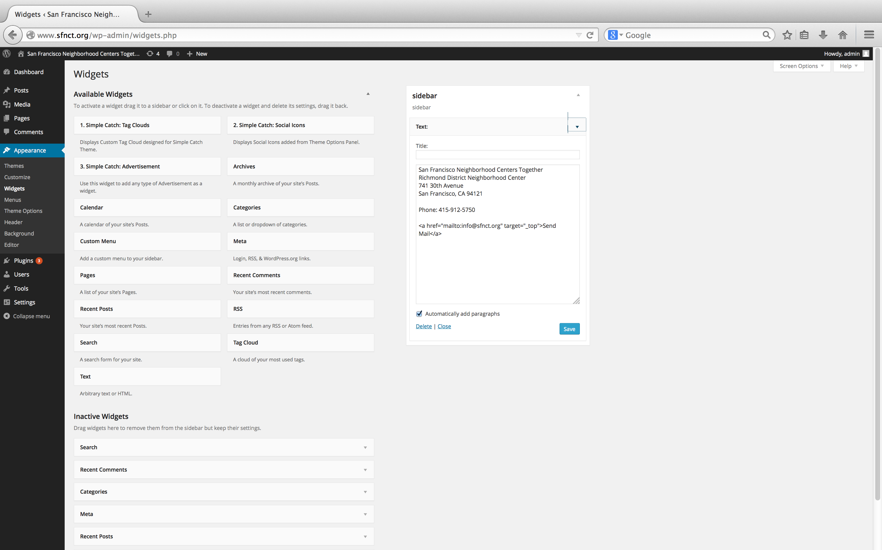

Figure : Administration Screen - Widgets

1. Log on the WordPress Administration for SFNCT.
2. From the Dashboard Screen, select “Appearance 🡪 Widgets” or go to <http://www.sfnct.org/wp-admin/widgets.php>
3. Open sidebar, edit the sidebar text, select the Save button.

## How Do I Customize Themes

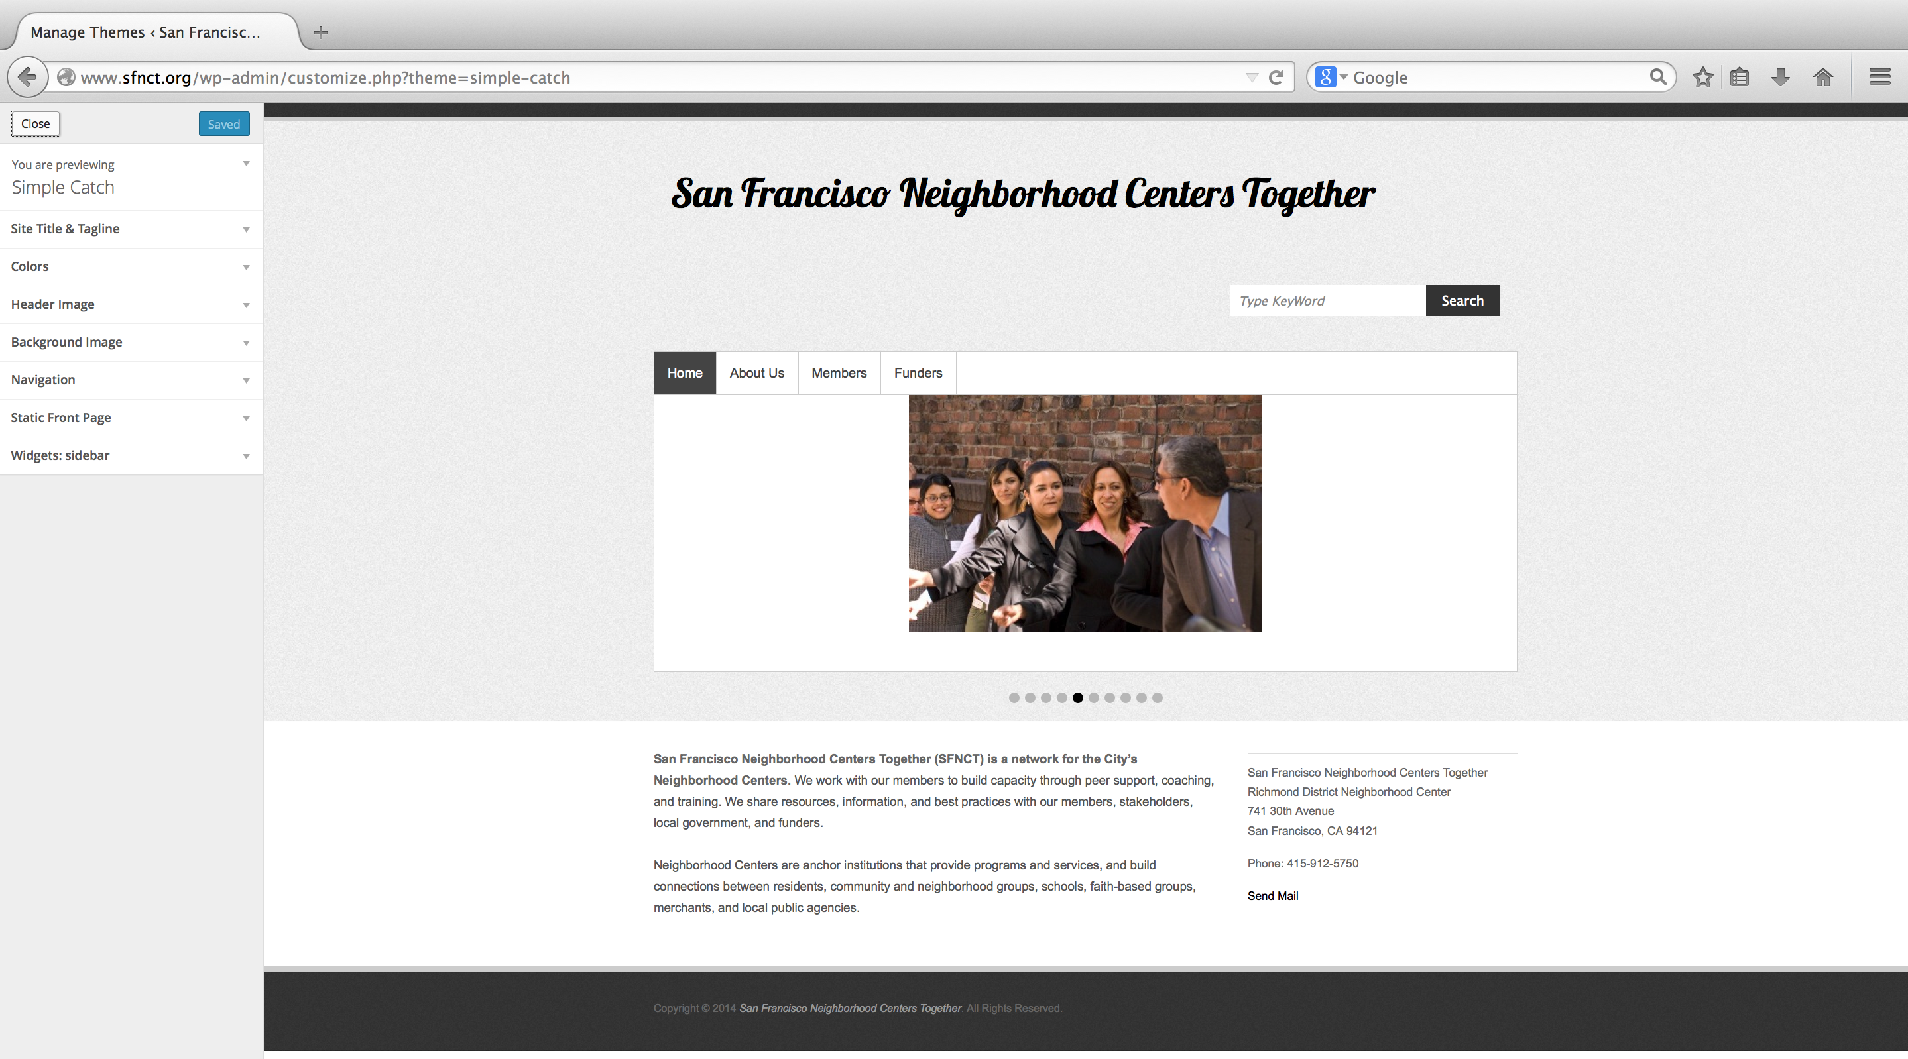

Figure : Administration Screen - Customize Theme

1. Log on the WordPress Administration for SFNCT.
2. From the Dashboard Screen, select “Appearance 🡪 Customize” or go to <http://www.sfnct.org/wp-admin/customize.php>
3. Use the left panel corner to customize the current theme. The customization includes items such as color schemes and navigation.

## How Do I Change Themes

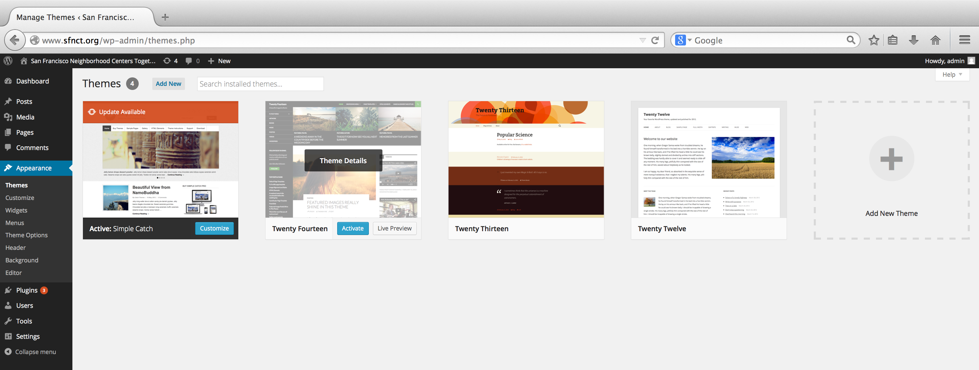

Figure : Administration Screen - Change Theme

1. Log on the WordPress Administration for SFNCT.
2. From the Dashboard Screen, select “Appearance 🡪 Themes” or go to <http://www.sfnct.org/wp-admin/themes.php>
3. The Administration Theme Screen displays which theme is active. Select the Active button of another theme to change themes.

# Member Only Announcements

The Member Only Announcements section allows SFNCT members to collaborate and broadcast announcements.

## Login Member Only Announcements

One needs to login SFNCT in order to access Members Only Announcement. If you have not logged into WordPress Administration for SFNCT, you will see the Login Member Only Announcement page asking for you to login. Enter your Username and Password and select the Log In button. If your credentials have been confirmed, you will be redirected to the intended page.

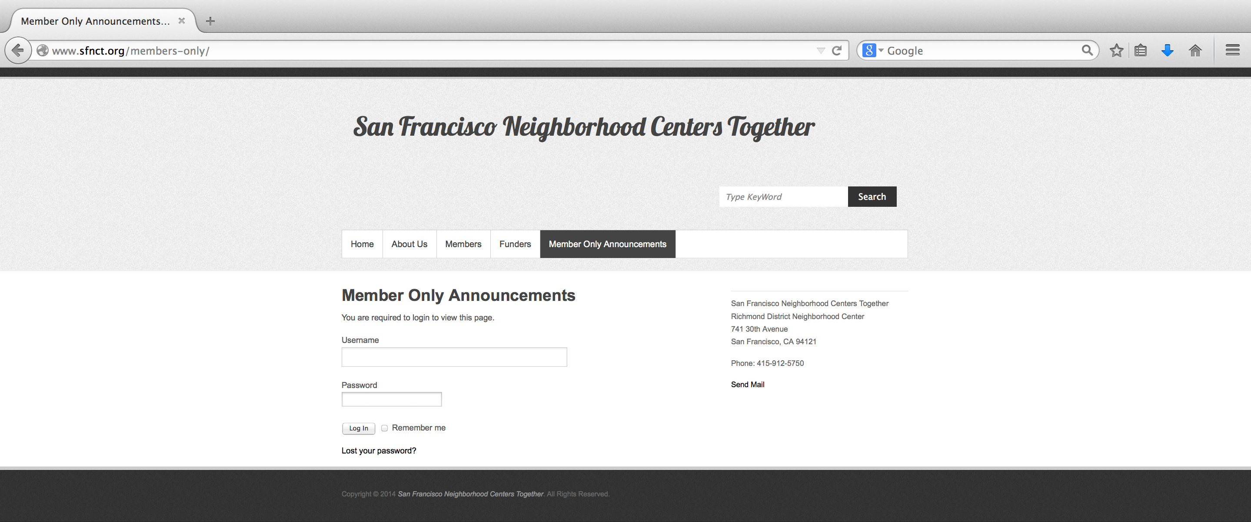

Figure : Login Member Only Announcements

## Member Only Announcements Dashboard

The Member Only Announcements Dashboard lists all the announcements. An announcement has a Title, Description, and perhaps an Attachment. Move the cursor over the title to view the announcement Description. You can open or save the attachment of the announcement by selecting the attachment link. Select the Edit link to update the Member Only Announcement and select the Delete link to delete a Member Only Announcement.

## 

Figure : Member Only Announcements Dashboard

## Edit Member Only Announcements

Once the user selects the Edit link from the Member Only Announcement Dashboard the user is redirected to the Edit Member Only Announcement page prepopulated with the selected announcement. Modify the Title input field, or the Description input field, or add, update, or delete attachments and select the Update button to persist changes. The user can change the name of the attachment without modifying the attachment itself. One can open or save the attachment of the announcement by selecting the attachment link.

## 

Figure : Edit Member Only Announcements

## 

## Delete Member Only Announcements

Select the Delete link to delete a Member Only Announcement from the Member Only Announcement Dashboard. Once the user selects the Delete link, a message is presented asking for confirmation. Select the Ok button to delete the announcement or select the Cancel button.

## Add Member Only Announcements

Update the Title input field, or the Description input field, or add, update, or delete attachments and select the Submit button to persist changes. The Title and Description are required fields. The user can add more than one attachment per announcement. The user can change the name of the attachment without modifying the attachment itself. One can open or save the attachment of the announcement by selecting the attachment link. The user is redirected to the Member Only Announcement Dashboard once an announcement has been successfully added.

## 

Figure : Add Member Only Announcements

## Member Only Announcements Attachments

A user can add, update, or delete Member Only Announcements from the Edit Member Only Announcement and Add Member Only Announcement pages. The user can add more than one attachment per announcement. The user can change the name of the attachment without modifying the attachment itself. One can open or save the attachment of the announcement by selecting the attachment link.

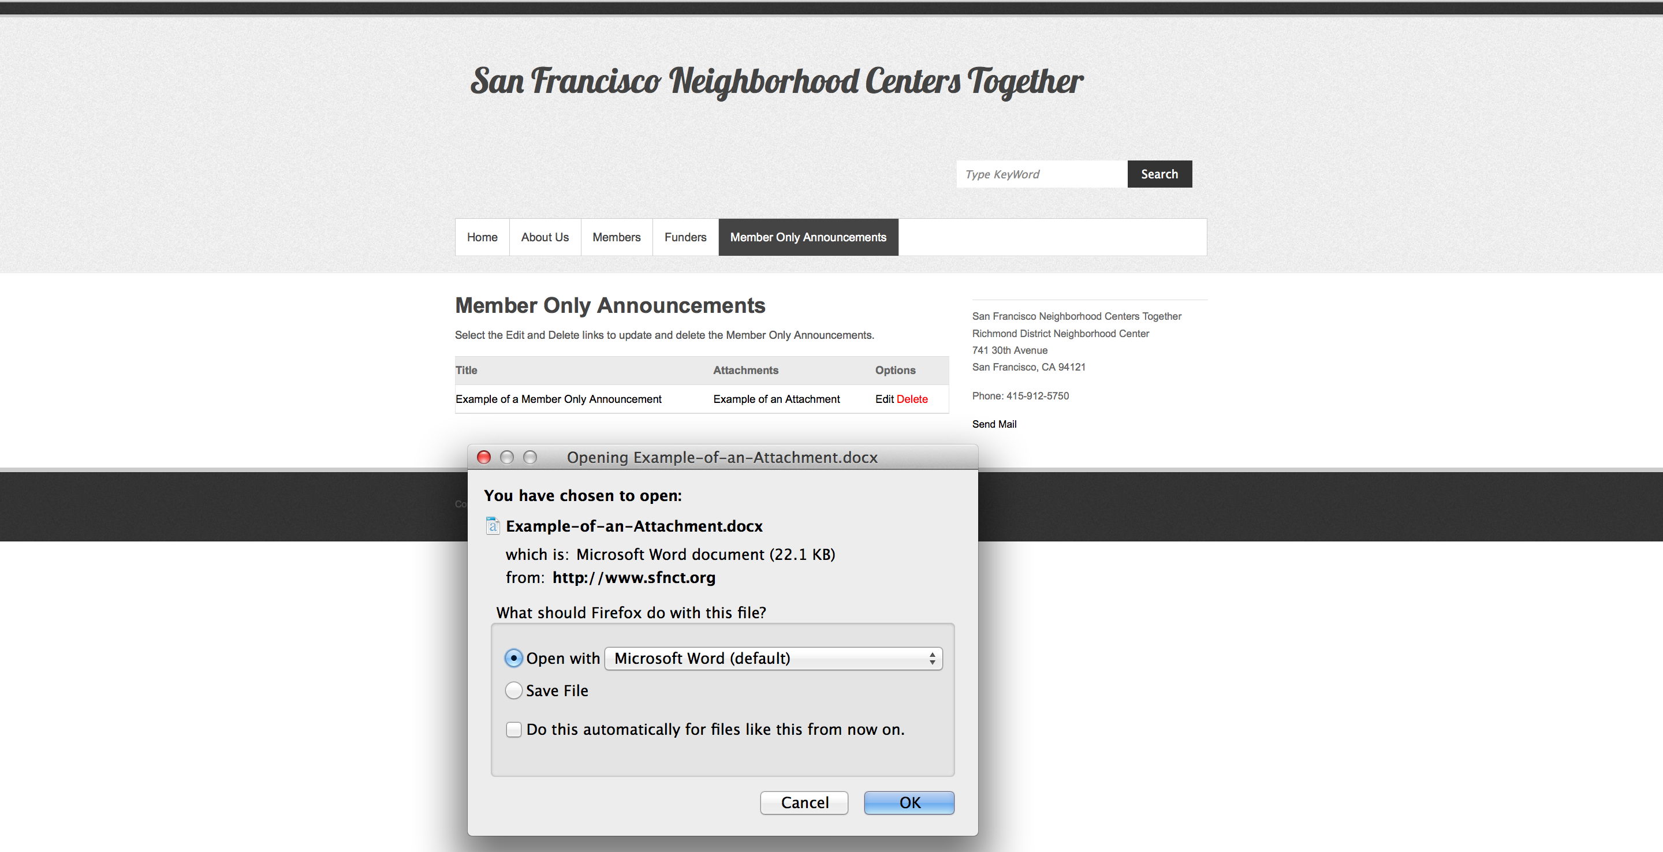

Figure 22: Member Only Announcements Attachments

The current attachment size limit is 2048 kilobytes. To increase the size limit, login the WordPress Administration for SFNCT. From the Dashboard Screen, select “WP User Frontend 🡪 WP User Frontend 🡪 Front Posting tab”. Update the Attachment max size field to desired amount and select the Save Changes button.

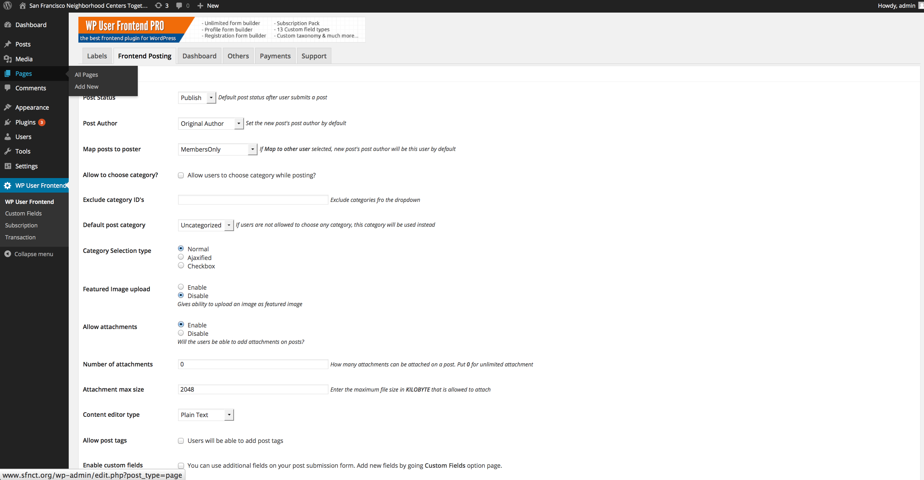

Figure 23: Attachment Max Size